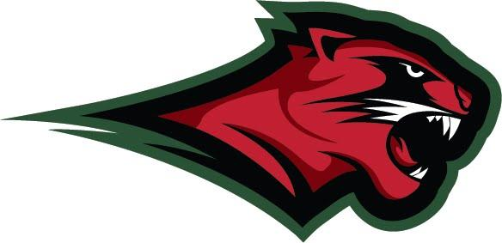

JAMESTOWN ATHLETICS

Website: www.jpsny.org/athletics

Twitter: @JHSRedRaiders

To: Board of Education

Dr. Kevin Whitaker

From: Ben Drake

Re: Proposed Mascot Plan

Date: June, 2023

Recently, the J.P.S. “Mascot Committee” met to discuss the issue of the J.H.S. “Red Raiders” nickname. Dr. Whitaker provided relevant background information to the committee and the expectations of the school district moving forward. One of the items he explained was the need for the Board of Education to approve a plan for the transition to a new nickname. Our committee is presenting the following proposed plan for your consideration:

June, 2023
- Conduct an “open forum” with students after spring break in April, 2023. This would include background information and education, discussion and a survey for students to provide their opinions.
- Recruit new student members to the mascot committee as past members have either graduated or are about to graduate this year.
- Poll students on possible new names.
- Poll community members and parents to gather possible new nicknames.
- The committee will accumulate feedback and generate a list of the most supported names.

July- August, 2023
- Conduct follow-up mascot committee meetings to discuss open forums and survey results.
- Conduct surveys (including students, parents, community, and alumni) in spring and summer of 2023 to narrow down the list of possible new names to a few.

September - December, 2023

- Conduct follow-up mascot committee meetings to discuss open forums and latest survey results as well as detail specific timeline for districtwide movement to new nickname.
- Mascot Committee to recommend a new nickname to the BOE by December 31, 2023.

June, 2024

- Identify and replace “Red Raiders” imagery and nickname with the new name by June 30, 2024.

June, 2025

- Replace any remaining more extensive “Red Raiders” graphics (i.e. football end zone/turf text, lettering on rear of home bleachers, etc) with the new name by June 30, 2025.

